Patient Statement Enhancement

Veterans Billing Statement

System Design Document



September 2020

Version 1.4

Department of Veterans Affairs

Revision History

| Date | Version | Description | Author |
| --- | --- | --- | --- |
| 09/04/2020 | 1.4 | Updated Content | Anthony Goddard |
| 12/11/2019 | 1.3 | Updated for version 2.0.11 | Michael McDougall |
| 09/16/2019 | 1.2 | Updated CCVBS web pages and images | Douglas Weinberg |
| 09/10/2019 | 1.1 | Updated content | Michael McDougall |
| 07/17/2019 | 1.0 | Technical Details | Michael McDougall |
| 05/15/2019 | 0.1 | Initial draft | S. Heiress |

| Activity | New Capability (1) | Feature Enhancement (2) |
| --- | --- | --- |
| **Field Deployment (A)** | Yes | Yes |
| **Cloud/Web Deployment (B)** | Yes | Yes |
| **Mobile Application (C)** | No | No |

Table of Contents

1 Introduction 1

1.1 Scope 1

2 Background 1

2.1 Overview of the System 1

2.2 Overview of the Business Process 2

2.3 Overview of the Significant Requirements 2

2.3.1 Functional Requirements 2

2.3.2 Security and Privacy Requirements 2

2.3.2.1 Encrypting Data at Rest 2

2.3.2.2 Encrypting Data in Communication 2

2.3.3 Single Sign-On Requirements 2

3 Conceptual Design 3

3.1 Conceptual Application Design 3

3.1.1 Application Context 3

3.1.2 High-Level Application Design 4

3.1.3 Application Locations 5

3.2 Conceptual Data Design 6

3.2.1 Project Conceptual Data Model 6

3.2.2 Database Information 6

3.2.3 User Interface Data Mapping 6

3.2.3.1 Application Screen Interface 7

3.2.3.1.1 Splash Page 10

3.2.3.1.2 Error Page/Contact Us Form 11

3.2.3.2 Application Report Interface 13

3.2.3.2.1 Check Digit Logic 20

3.2.3.3 Unmapped Data Element 22

3.3 Conceptual Infrastructure Design 23

3.3.1 System Criticality and High Availability 23

3.3.1.1 Web Processing 23

3.3.1.2 File Storage 23

3.3.1.3 Data Storage 23

3.3.1.4 System Monitoring 23

3.3.2 Special Technology 23

3.3.3 Technology Locations 23

3.3.4 Conceptual Infrastructure Diagram 24

3.3.4.1 Location of Environments and External Interfaces 24

3.3.4.2 Conceptual Production String Diagram 24

4 System Architecture 25

4.1 Hardware Architecture 25

4.2 Software Architecture 27

4.3 Network Architecture 28

4.4 Service Oriented Architecture / ESS 28

4.5 Enterprise Architecture 28

5 Data Design 28

5.1 DBMS Files 28

5.2 Non-DBMS Files 30

5.3 Data View 30

6 Detailed Design 31

6.1 Hardware Detailed Design 31

6.2 Software Detailed Design 33

6.2.1 Conceptual Design 33

6.2.1.1 Product Perspective 33

6.2.1.1.1 User Interfaces 34

6.2.1.1.2 Hardware Interfaces 34

6.2.1.1.3 Software Interfaces 35

6.2.1.1.4 Exception Handling 35

6.2.1.1.5 Communications Interfaces 35

6.2.1.1.6 Memory Constraints 35

6.2.1.1.7 Special Operations 35

6.2.1.2 Product Features 35

6.2.1.3 User Characteristics 36

6.2.1.4 Dependencies and Constraints 36

6.2.2 Specific Requirements 36

6.2.2.1 Database Repository 36

6.2.2.2 System Features 36

6.2.2.2.1 Routines (Entry Points) 36

6.3 Network Detailed Design 39

6.4 Security and Privacy 39

6.4.1 Security 39

6.4.2 Privacy 39

6.5 Service Oriented Architecture / ESS Detailed Design 40

7 External System Interface Design 40

7.1 Interface Architecture 40

7.2 Interface Detailed Design 40

7.2.1 CCPC Interface 40

7.2.1.1 Statement Data 40

7.2.1.2 Station Data 42

7.2.2 IAM Interface 44

7.2.2.1 Access VA 44

7.2.2.2 Reverse Proxy / Mutual SSL 45

7.2.2.3 Authentication Traits / DFN 45

7.2.2.4 Logout 46

8 Human-Machine Interface 46

8.1 Interface Design Rules 46

8.2 Inputs 46

8.3 Outputs 47

8.4 Navigation Hierarchy 47

8.4.1 Screen 1 48

8.4.2 Screen 2 48

8.4.3 Screen 3 49

9 Attachment A – Approval Signatures 51

A. Additional Information 52

A.1. Identification of Technology and Standards 52

A.2. Packaging and Installation 53

List of Tables

Table 1: User Access to Veteran Billing System (CCVBS) GUI 1

Table 2: Application Context Description – Object – Interfaces Internal to OIT 3

Table 3: Objects to be Built or Modified in the High Level Application Design 5

Table 4: Internal Data Stores 5

Table 5: Application Locations 5

Table 6: Database Inventory 6

Table 7: Splash Screen Description 11

Table 8: CCVBS Statement Description 13

Table 9: Alpha & Special Characters Conversion Table 18

Table 10: CCPC Statement Batch File Flat File Format 37

Table 11: Station Data 39

Table 12: List of Technologies 49

Table 13: List of Open Source Tools Used within CCVBS 50

List of Figures

Figure 1: Application Context Diagram 3

Figure 2: High-Level Application Design 4

Figure 3: Conceptual Data Model 6

Figure 4: CCCCVBS Logon Page 7

Figure 5: CCVPS Statement Page 8

Figure 6: Open PDF Button Displays PDF in New Browser Tab 9

Figure 7: View Statement Button Displays CCVBS in New Browser Tab 9

Figure 8: Splash Screen 10

Figure 9: Page with No CCVBS Statement Available 11

Figure 10: Error Page 11

Figure 11: Contact Form 12

Figure 12: Success Message after Contact Form Submissions 12

Figure 13: SNS Message Sent to Email Distribution Group 13

Figure 14: CCVBS Statement 14

Figure 15: Data Model 19

Figure 16: Networks and Environments 24

Figure 17: Conceptual Production String Diagram 24

Figure 18: Hardware Architecture 25

Figure 19: Application Context Diagram 26

Figure 20: Software Architecture Layers 27

Figure 21: VPC Configuration 28

Figure 22: Data Architecture 30

Figure 23: Specifications for EC2 T2 Instances 32

Figure 24: Product Perspective 33

Figure 25: Hardware Interfaces 34

Figure 26: Software Interfaces 35

Figure 27: CCVBS Application Projects 36

Figure 28: CCVBS Domain Objects 37

Figure 29: CCVBS.Repository.DynamoDB Properties and Methods 37

Figure 30: CCVBS.Services Properties and Methods 38

Figure 31: CCVBS Application Properties and Methods 39

Figure 32: AccessVA Home Page 44

Figure 33: CCVBS Login Options 45

Figure 34: CCVBS – View Statement Options 47

Figure 35: Navigation 47

Figure 36: Statement Selection 48

Figure 37: Example of HTML Page of Sample Billing Statement (1 of 2) 48

Figure 38: Example of HTML Page of Sample Billing Statement (2 of 2) 49

Figure 39: Example of PDF Page of Sample Billing Statement (1 of 2) 49

Figure 40: Example of PDF Page of Sample Billing Statement (2 of 2) 50

# Introduction

The Veterans Health Administration (VHA) Chief Business Office (CBO) is requesting software enhancements to satisfy the following congressional directive:

Veterans Benefits and Transition Act of 2018

Delivery of debt notices by standard mail and electronic means.—The Secretary shall develop a method by which individuals may elect to receive notice of debt by electronic means and shall ensure, to the extent practicable, that the letter developed is delivered by both standard mail and by electronic means to intended recipients.

The Patient Statement Enhancement (PSE) Veterans Billing Statement (CCVBS) project will allow Veterans secured access to the last six months of their billing statements online.

## Scope

Significant functional requirements are available in [GITHUB - PSE CCVBS SLA](https://github.com/department-of-veterans-affairs/vbs-product/blob/master/pm/VBS-Production-SLA-v1-10212019-Final.pdf)

User Profiles

Table 1: User Access to Veteran Billing System (CCVBS) GUI

| Users | Item/Format | Application | Note |
| --- | --- | --- | --- |
| Veterans | PDF | CCVBS | Veterans must be registered with VA IAM access: either DS Logon or ID.me userid and password, or a MHV Level 2 access or above. |

# Background

## Overview of the System

The system will allow the Veteran to access an online copy of their billing statements that they currently receive by mail. The components for the system will reside entirely in the VAEC Amazon Web Services (AWS) govcloud. The Consolidated Copayment Processing Center (CCPC) mainframe application that currently processes paper statements will transfer the data via SFTP to the CCVBS application. A background Statement Processing Service will retrieve that data, parse it, and send the Statement Data to a Statement Data Service component, which will store it in a Dynamo DB database repository.

When a Veteran accesses the CCVBS Web App with a fully qualified logon, through AccessVA, (with a DSLogon, an ID.me logon or an elevated Identity and Access Management [IAM] acceptable MHV login), the billing statement can be chosen from a list of available statements in a pull-down field. This list includes the last 6 months of billable transactions, arranged by facility and by date. Once the View button is selected by the Veteran, the chosen statement will appear in a separate window that resembles that appearance of the standard CCPC-mailed statements.

The Veteran can also choose to download / print the statement as a PDF or retrieve a statement for a different date or medical facility. The perforated section at the bottom of the printable statement can be sent back with the Veteran’s payment in the mail.

## Overview of the Business Process

Significant functional requirements are available in [GITHUB - CCVBS](https://github.com/department-of-veterans-affairs/vbs-product)

## Overview of the Significant Requirements

### Functional Requirements

Significant functional requirements are available in [GITHUB - CCVBS](https://github.com/department-of-veterans-affairs/vbs-product)

### Security and Privacy Requirements

Throughout the Assessment and Authorization (A&A) process, the CCVBS team will work with the assigned Information Security Officer (ISO) to obtain an Authority to Operate (ATO) for access to the Governance, Risk, and Compliance (GRC) tool for the A&A process. The GRC tool will be used to document accreditation requirements including technical testing/scans, security documentation, and actions identified during the Security Control Assessment. The completion of the required security documentation and technical tests will enable the Office of Cyber Security (OCS) Certification Program Office (CPO) to determine the final risks based on the vulnerabilities in the information system; assess reduce or eliminate planned, completed, or corrective actions; make a final determination on the acceptability of risk to VA; and prepare the final accreditation decision letter. CCVBS team will work with ISO to meet the accreditation requirements and submit them for review and approval.

#### Encrypting Data at Rest

Data is stored in two locations within CCVBS. Statement data is received as a Zip file that is stored onto AWS S3. This zip file is password encrypted with standard AES-256 encryption. Application data is stored within AWS Dynamo DB. All data within Dynamo DB is encrypted at REST with AWS managed keys ([Dynamo DB Encryption](https://docs.aws.amazon.com/amazondynamodb/latest/developerguide/EncryptionAtRest.html)). No data is stored on the end user device (browser client) via browser cookies or other mechanisms. When the user logs out, navigates away, or is timed out from the CCVBS web application, no PII or PHI is cached or stored on their device.

#### Encrypting Data in Communication

There are two protocols used for communication within CCVBS: SSL and SFTP. Both of these protocols use encryption over the wire.

### Single Sign-On Requirements

CCVBS uses VA IAM SSOe (Single Sign-On External) – for authentication of CCVBS users. The User must login through the [AccessVA](https://access.va.gov/accessva/) to get authenticated to use the CCVBS application. The CCVBS application will integrate with IAM SSOe authentication solution for external facing (Internet) Veterans. Veterans login by using DS Logon, ID.me, or fully-qualified MHV access through the AccessVA portal. The IAM integration provides identification traits for the Veteran including the VistA Data File Number (DFN) which is used to pull the correct statement data for the authenticated user.

Administrators of the CCVBS application login to the AWS console via Single Sign On with PIV authentication via [VAEC AWS Console Single Sign On](https://prod.adfs.federation.va.gov/adfs/ls/idpinitiatedsignon.aspx).

# Conceptual Design

## Conceptual Application Design

### Application Context

Figure 1: Application Context Diagram

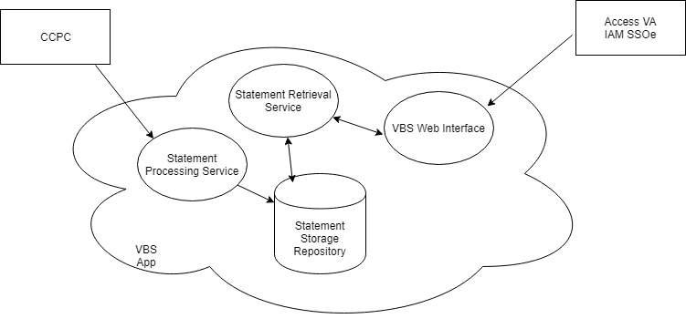

Table 2: Application Context Description – Object – Interfaces Internal to OIT

| ID | Name | Related Object | Input Messages | Output Messages | External Party |
| --- | --- | --- | --- | --- | --- |
| CCPC | CCPC | CCPC Mainframe System | No Input. Data is pushed via SFTP | Statement Data | NA |
| IAM | IAM | IAM SSOe | User Logins | DFNs passed via Http Header | NA |

### High-Level Application Design

Figure 2: High-Level Application Design



Table 3: Objects to be Built or Modified in the High Level Application Design

| ID | Name | Description | Service or Legacy Code | External Interface Name | External Interface ID | SDP Sections 1&2 |
| --- | --- | --- | --- | --- | --- | --- |
| SFTP | SFTP Server | Receives statement batch files | Service | CCPC | CCPC | Being Developed |
| StatementProcessing | Statement Processing Service | Processes statement batch files | Service |  |  | Being Developed |
| Nginx | Nginx reverse proxy | Reverse proxy with mutual SSL | Service | IAM | IAM | Being Developed |
| CCVBSWeb | CCVBS Web App | Lambda for web application | Service |  |  | Being Developed |
| StatementRepository | Statement Repository Component | Shared library for data persistence | Service |  |  | Being Developed |

Table 4: Internal Data Stores

| ID | Name | Data Stored | Steward | Access |
| --- | --- | --- | --- | --- |
| Statement repository | Statement Repository | Statement Data | Receiving Organization | Save Statements / Query for Statements by DFN |

### Application Locations

Table 5: Application Locations

| Application Component | Description | Location at Which Component is Run | Type | Contact |
| --- | --- | --- | --- | --- |
| CCPC | CCPC Mainframe Application – Prints Paper Statements | AITC | Integration Partner | [David.Miskolczi@va.gov](mailto:David.Miskolczi@va.gov),  [CCPDev_ProdTeam@va.gov](mailto:CCPDev_ProdTeam@va.gov) |
| IAM SSOe | Single Sign On External – Veteran Login and Authentication | Azure Govcloud | Integration Partner | [LeeAnne.Branum@va.gov](mailto:LeeAnne.Branum@va.gov),  [IAMProjectManagers@va.gov](mailto:IAMProjectManagers@va.gov) |
| CCVBS Application | Online Statements | AWS Govcloud | This System | [Shervic.Prouse@va.gov](mailto:Shervic.Prouse@va.gov),  [CCVBSsupportgroup@va.gov](mailto:vbssupportgroup@va.gov) |

## Conceptual Data Design

### Project Conceptual Data Model

Figure 3: Conceptual Data Model

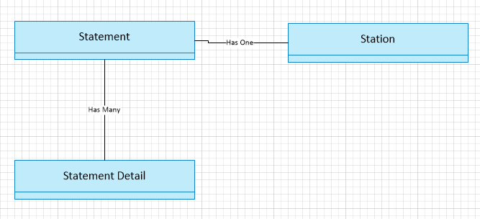

### Database Information

Table 6: Database Inventory

| Database Name | Description | Type | Steward |
| --- | --- | --- | --- |
| Statement Data Repository | Dynamo DB Database in AWS | Create | CCVBS Receiving Organization |

### User Interface Data Mapping

The CCVBS statement is available as a PDF download for the Veteran. Once logged in and authenticated, a splash screen will appear in browser such as Internet Explorer, Chrome, or Firefox. The Veteran will be able to view the CCVBS statement embedded inside the browser window.

Figure : CCCCVBS Logon Page

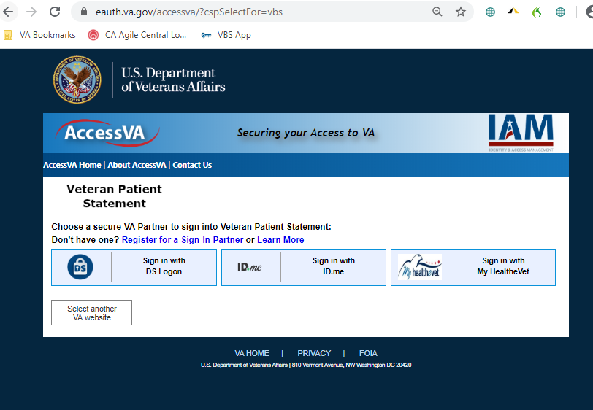

#### Application Screen Interface

There are 2 application screen interfaces or HTML pages that can be viewed by the Veteran. The first splash page contains a drop-down menu will populate with different select options or statement IDs that are available to specifically to the Veteran. Once a required date is selected, the Veteran clicks either **View Statement** or **Open PDF** button to view the Adobe PDF file embedded in the browser window on the second page.

Figure 5: CCVPS Statement Page

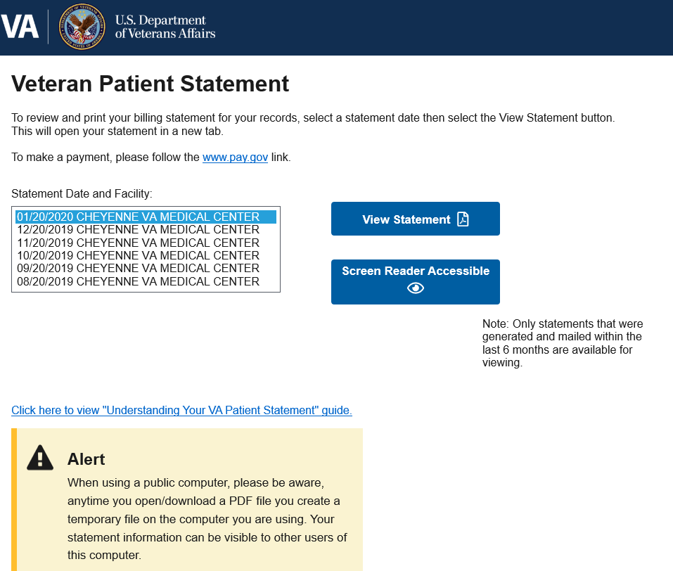

Figure 6: Open PDF Button Displays PDF in New Browser Tab

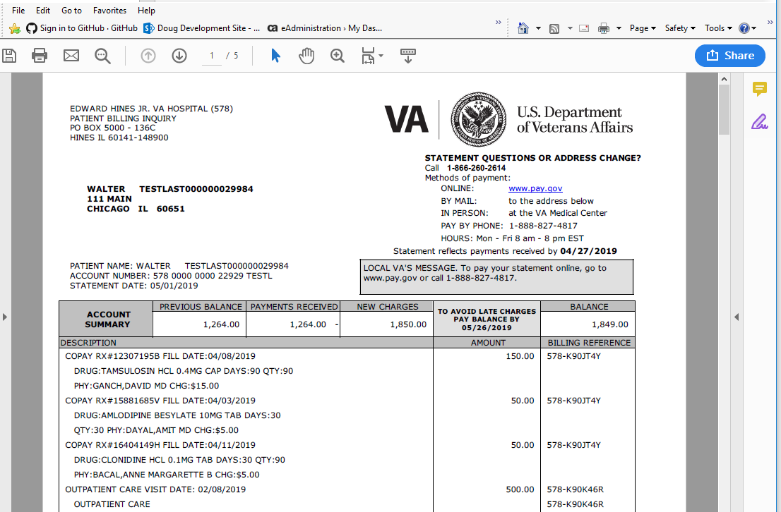

Figure : View Statement Button Displays CCVBS in New Browser Tab

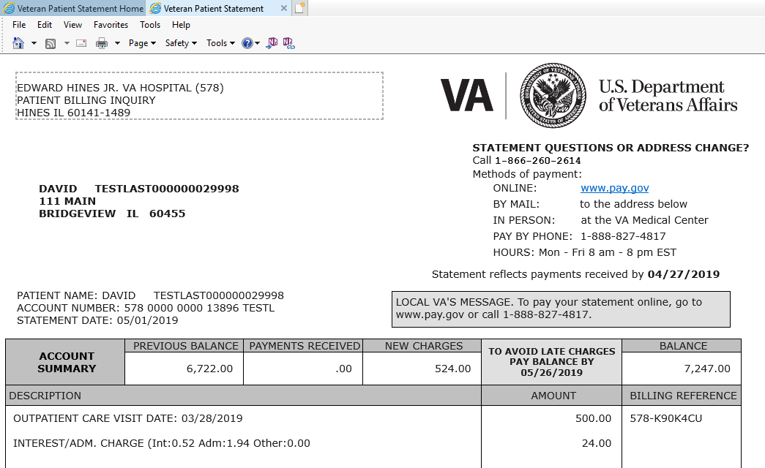

##### Splash Page

The splash page is the screen that contains an HTML form with a drop-down menu with two buttons: View Statement and Screen Reader Accessible. Splash page also contains an alert message for users to be careful when downloading a PDF on a public/shared computer like those found in libraries or internet cafes.

Figure : Splash Screen

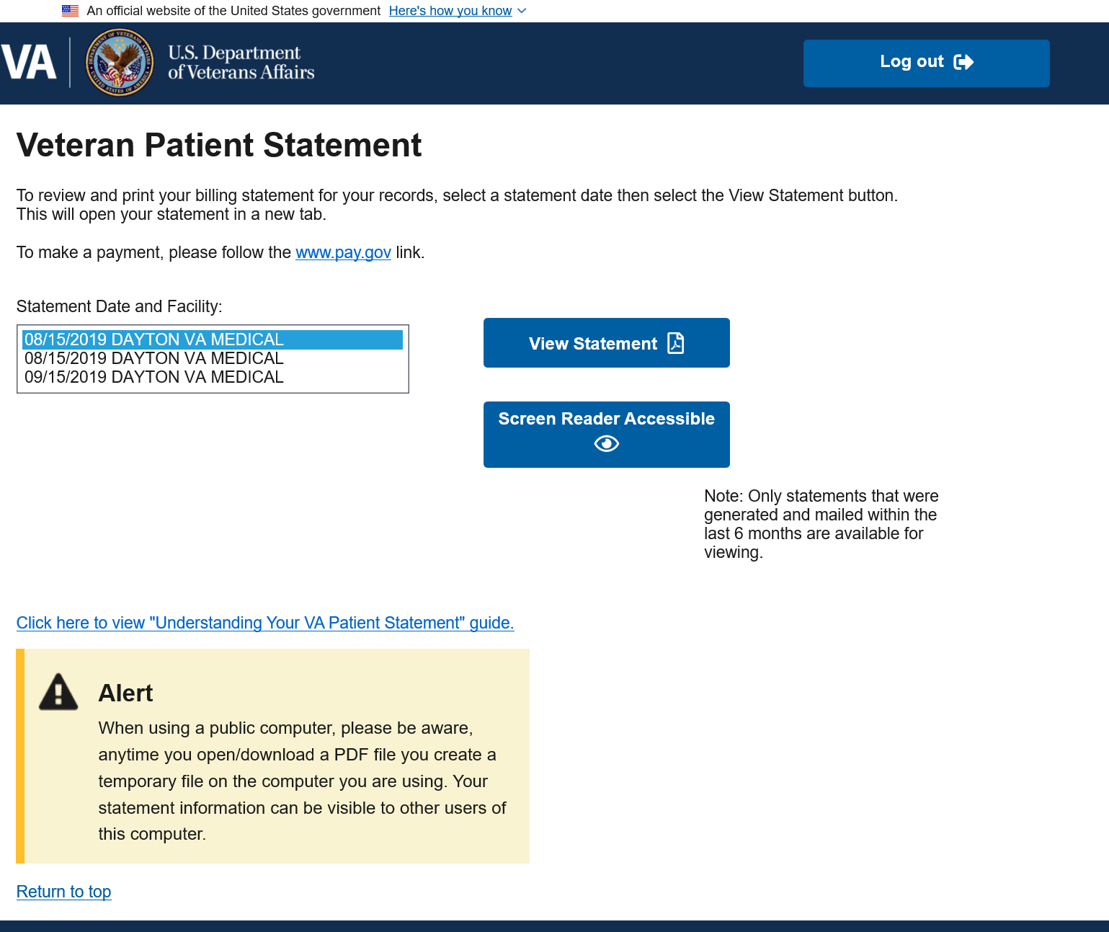

* **View Statement** button: Opens a new browser tab and displays the veteran statement embedded inside the browser window as a pdf document ready for printing.
* **Screen Reader Accessible** button: Opens a new browser tab and displays the veteran statement in plain HTML and completely 508 compliant.

1. Both View Statement and Screen Reader Accessible buttons open exactly the same Veteran Patient Statement.

* **Log Out button**: redirects Veteran back to the Access VA website.

Page with no statement available. In certain cases, a CCVBS statement may not be available. If this is true, then a message appears below the menu as shown in the diagram below.

Figure : Page with No CCVBS Statement Available

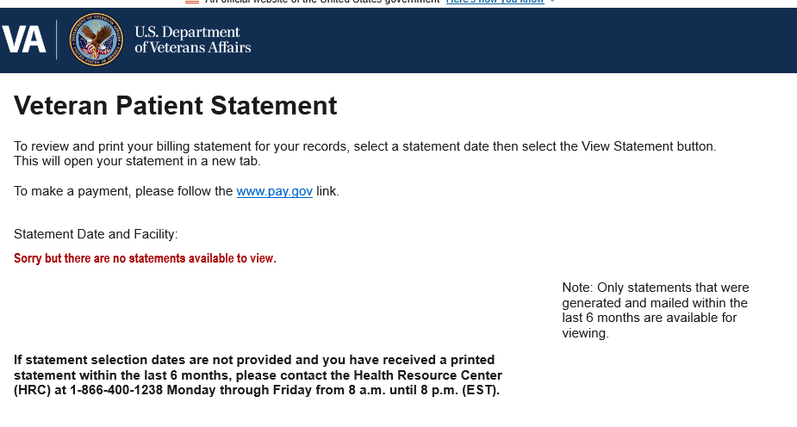

##### Error Page/Contact Us Form

Anytime the system detects an error, the end user will automatically be redirected to a default error page as shown in the next diagram:

Figure : Error Page

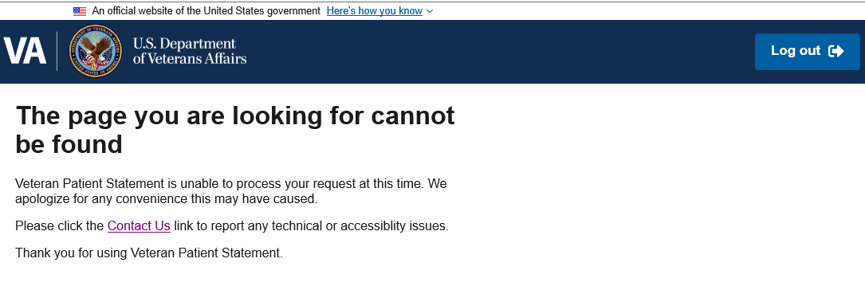

Should the end user decide to click on the “Contact Us” hyperlink, a new page is displayed as shown in Figure 11.

Contact Us form has 2 required fields: the radio button group describing the issue and the email address.

The issue description field will contain up to 1000 characters to describe this issue in further detail. This field is completely optional and is not required to be filled out. The form contains field validations scripts to maintain data integrity to ensure at least one radio button has been selected and the email address is in the correct email format. Once the data passes validation, the form is successfully submitted, AWS retrieves the information and uses a Simple Notification Service (SNS) (see Figure 11) to pass the form data to an email distribution group. Members of the group will receive the form data.

Figure : Contact Form

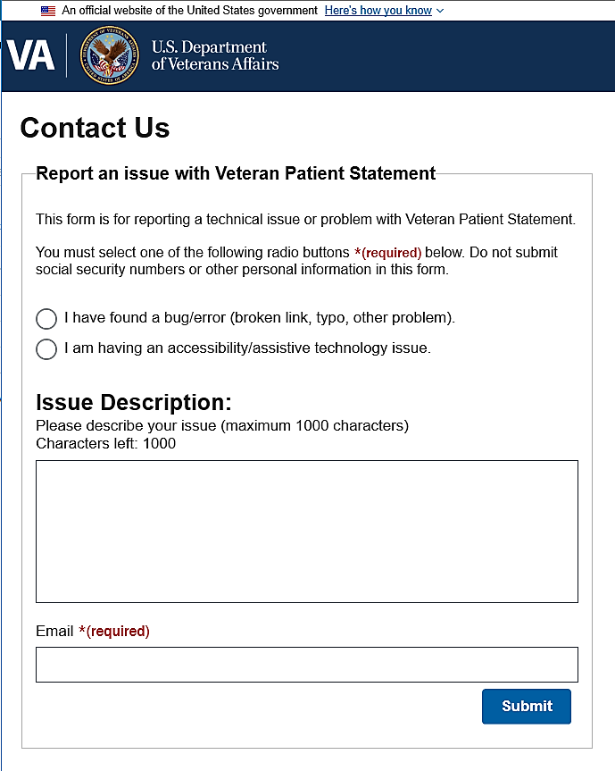

Figure : Success Message after Contact Form Submissions

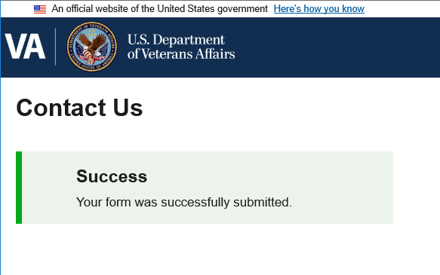

Figure : SNS Message Sent to Email Distribution Group

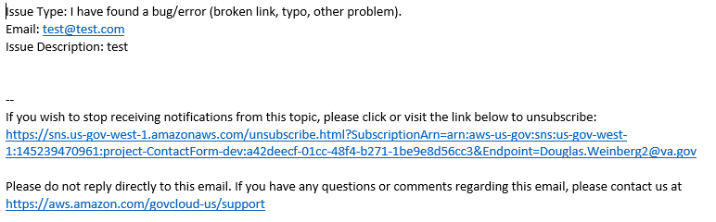

Table 7: Splash Screen Description

| Graphical User Interface (GUI) Field | Table (Database Table that field connects to) | Field (Field in Table that the GUI field connects to) | Comments |
| --- | --- | --- | --- |
| StatementID | Statement | Id (guid)  PH_ADDRESS_1  PH_ADDRESS_2  PH_ADDRESS_3  PH_AMT_DUE  PH_CITY  PH_DFN_NUMBER  PH_Large_Font_Indcator  PH_NEW_BALANCE  PH_NUM_OF_LINES  PH_PATIENT_FST_NME  PH_PATIENT_LST_NME  PH_PATIENT_MID_NME  PH_PREV_BAL  PH_R_O_PARA_CDES  PH_SPECIAL_NOTES  PH_STATE  PH_TOT_CHARGES  PH_TOT_CREDITS  PH_ZIP_CDE  PS_FAC_PHONE_NUM  PS_FACILITY_NUM  PS_PROCESS_DATE  PS_SEQ_NUM  PS_STATEMENT_DATE  PS_STATEMENT_VAL  PS_TOT_SEQ_NUM  PS_TOT_STATEMENT | Table is AWS DynamoDB database |

#### Application Report Interface

The report in this case is the CCVBS statement that is viewable as an embedded PDF document in the browser window (Figure 14).

Figure 14: CCVBS Statement

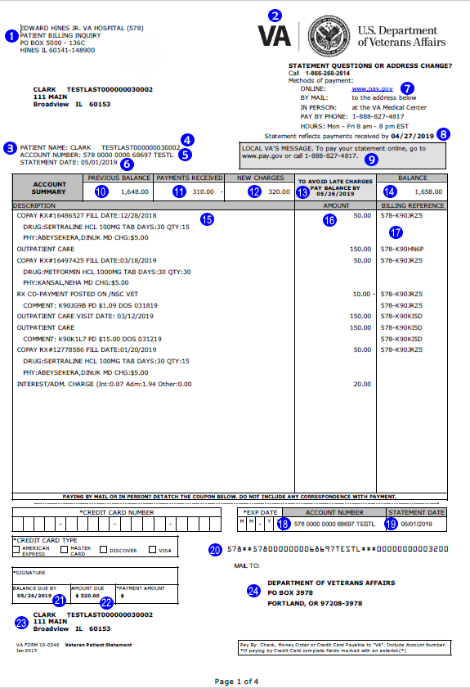

Table 8: CCVBS Statement Description

| # | PDF Field | Field Requirements | Database Field |
| --- | --- | --- | --- |
| 1 | RETURN ADDRESS. | This the primary site address.  The mailing address of the local VAMC that supports the Veteran. This address will be used as a “return address” if the consolidated billing statement cannot be delivered to the Veterans “address on record” in VistA.  The return address comes from the Station table file. | Station.FACILITY_DESC  Station.STAT_ADDRESS_1  Station.STAT_ADDRESS_2  Station.CITY  Station.STATE  Station.ZIP_CDE |
| 2 | VA Logo | Alternate Text: VA LOGO | https://s3.amazonaws.com/CCVBS-images/VA-logo.png |
| 3 | Mail to Address | Address for the Veteran on file from the primary site. | Statement.PH_PATIENT_FST_NME  Statement.PH_PATIENT_MID_NME  Statement.PH_PATIENT_LST_NME  Statement.PH_ADDRESS_1  Statement.PH_ADDRESS_2  Statement.PH_ADDRESS_3  Statement.PH_CITY  Statement.PH_STATE  Statement.PH_ZIP_CDE |
| 4 | PATIENT NAME: | Name patient on file from the primacy site. | Statement.PH_PATIENT_FST_NME  Statement.PH_PATIENT_MID_NME  Statement.PH_PATIENT_LST_NME |
| 5 | ACCOUNT NUMBER: | Format: DFN (of the primary site) + first 5 characters of the Patient’s Last Name  3-characters <space> 4-characters<space> 4-characters <space> remaining characters | Statement.PH_DFN_NUMBER |
| 6 | STATEMENT DATE: | The date the new Consolidated Billing Statement System (CBSS) will generate the Consolidated Billing Statement (CBS) data file and send it to the AITC each month. | Statement.PS_STATEMENT_DATE |
| 7 | CALL | The phone number of the HRC Call Center facility that supports the Veteran.  The phone number to print on the statement comes from the Station Table file. | Statement.Station.TEL_NUM |
| 8 | Statement reflects payments received by [DATE] | This is the local VAMC’s cut-off date. The “cut-off date” is the date the local VAMC generates their local Patient Statement data file and transmits it to the new Consolidated Billing Statement System (CBSS) on a monthly basis. | Statement.PS_PROCESS_DATE |
| 9 | LOCAL VA’S MESSAGE | Data value from the Special Notes field from the primary site.  If the value from the primary site “NOT A BILL” the data is ignored and not included in the message box.  The text “LOCAL VA’S MESSAGE” is part of the form template and is always included the value from the site data is appended to this template text. | Statement.PH_SPECIAL_NOTES |
| 10 | PREVIOUS BALANCE | The balance from the previous consolidated billing statement.  If no previous statement exists print: 0.00 | Statement.PH_PREV_BAL |
| 11 | PAYMENTS RECEIVED | Grand total of all “PAYMENTS POSTED ON mm/dd/yyyy” for all facilities listed on the consolidated billing statement.  The dollar amount is shown followed by a negative sign.  If no payments are received within the statement period print: 0.00 | Statement.PH_TOT_CREDITS |
| 12 | NEW CHARGES | The grand total of all new charges from each facility.  This value will be the grand total of all “FACILITY xxx TOTALS”.  If no new charges are incurred within the statement period print: .00 | Statement.PH_TOT_CHARGES |
| 13 | TO AVOID LATE CHARGES PAY BALANCE BY… | If the Veteran has balance due, this date is 25 calendar days from the statement date.  If there is a credit balance for the statement, due date and text is replaced by the following text: NO PAYMENT DUE | Based on value of Statement.PH_NEW_BALANCE  If less than 0, no balance is due, otherwise message appears “TO AVOID LATE CHARGES PAY BALANCE BY” and Statement.PS_STATEMENT_DATE |
| 14 | BALANCE | If there is a credit balance for the statement, the dollar amount is shown followed by “CR”. (i.e., 250.00CR) | Statement.PH_NEW_BALANCE |
| 15 | DESCRIPTION | Each line in the transaction detail table (description, amount, & billing reference) is a “Patient Detail” record from the FPS file.  Each line is displayed in the same order as the detail records appear in the FPS file.  Special Handling of specific Patient Detail records:  For an RX PD record, change: “RX:” 🡪 “RX#” and “FD” 🡪 “FILL DATE”  Example:  PD Record Received: COPAY RX:20025863E FD:07/31/2012 PD Record Printed: COPAY RX#20025863E FILL DATE:07/31/2012  For Payment detail records, change  “PAYMENT” 🡪 “PAYMENT POSTED ON”  Example: PD Record Received: PAYMENT (08/10/2012) PD Record Printed: PAYMENT POSTED ON 08/11/2012  For Patient Care detail records, remove: (NSC)  OUTPATIENT CARE(NSC) VISIT DATE: 09/13/2012 🡨 Remove “(NSC) HOSPITAL CARE(NSC) VISIT DATE: 09/13/2012 🡨 Remove “(NSC)  Example: PD Record Received: OUTPATIENT CARE(NSC) VISIT DATE: 09/13/2012 PD Record Printed: OUTPATIENT CARE VISIT DATE: 09/13/2012  If the CBS is a late statement, see sample in this document for additional text to add informing the Veteran that the statement is additional for the month. | StatementDetail.PD_TRANS_DESC |
| 16 | AMOUNT | Dollar amounts including site total align at the decimal point  A dollar amount followed by a negative (-) sign will be used for payments or other credits to the account.  If the dollar amount is 0.00 (zero), then the amount is blank (not shown) for the detailed line item on the statement. | StatementDetail.PD_TRANS_AMT |
| 17 | BILLING REFERENCE | Center aligned within the cell. | StatementDetail.PD_REF_NO |
| 18 | ACCOUNT NUMBER | Layout Format: DFN (of Primary site) + first 5 characters of the Patient’s Last Name  3‑characters <space> 3‑characters<space> 4‑characters<space> remaining characters | Statement.PH_DFN_NUMBER |
| 19 | STATEMENT DATE | The date the new Consolidated Billing Statement System (CBSS) will generate the Consolidated Billing Statement (CBS) data file and send it to the AITC each month. | Statement.PS_STATEMENT_DATE |
| 20 | OCR Scan Line | Components of the Scan Line in the coupon:   * Facility Number = first 5 characters   + Left justified, extra digits asterisk filled * Account # = next 24 characters   + Left justified, extra digits asterisk filled * Miscellaneous Amount = next 4 characters   + Always zero filled value: 0000 * Amount Due = next 9 characters   + Right justified with leading zeros * Check Digit = last single character of the scan line.   **NOTE:** Refer to general requirements for logic to generate the check digit. | Statement.PS_FACILITY_NUM  Statement.PH_TOT_CHARGES |
| 21 | BALANCE DUE BY | If statement balance is a credit balance, the print the following text: NO PAYMENT DUE | Statement.PS_STATEMENT_DATE |
| 22 | AMOUNT DUE | If statement balance is a credit balance, then amount due is: 0.00 | Statement.PH_TOT_CHARGES |
| 23 | Veteran Address | Address for the Veteran on file from the primary site. | Statement.PH_PATIENT_FST_NME  Statement.PH_PATIENT_MID_NME  Statement.PH_PATIENT_LST_NME  Statement.PH_ADDRESS_1  Statement.PH_ADDRESS_2  Statement.PH_ADDRESS_3  Statement.PH_CITY  Statement.PH_STATE  Statement.PH_ZIP_CDE |
| 24 | MAIL TO: | The return address to print on the coupon comes from the Station Table file.  **NOTE:** A barcode in the MAIL TO address section of the coupon is not needed. | No field. |

Figure 15: Data Model

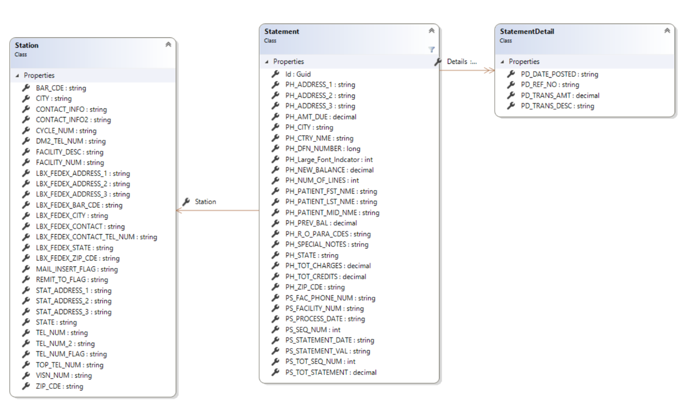

##### Check Digit Logic

| Digit Position | Digit Value |
| --- | --- |
| 1 | 2 |
| 2 | 1 |
| 3 | 2 |
| 4 | 1 |
| 5 | 2 |
| 6 | 1 |
| 7 | 2 |
| 8 | 1 |
| 9 | 2 |
| 10 | 1 |
| 11 | 2 |
| 12 | 1 |
| 13 | 2 |
| 14 | 1 |
| 15 | 2 |
| 16 | 1 |
| 17 | 2 |
| 18 | 1 |
| 19 | 2 |
| 20 | 1 |
| 21 | 2 |
| 22 | 1 |
| 23 | 2 |
| 24 | 1 |
| 25 | 2 |
| 26 | 1 |
| 27 | 2 |
| 28 | 1 |
| 29 | 2 |
| 30 | 1 |
| 31 | 2 |
| 32 | 1 |
| 33 | 2 |
| 34 | 1 |
| 35 | 2 |
| 36 | 1 |
| 37 | 2 |
| 38 | 1 |
| 39 | 2 |
| 40 | 1 |
| 41 | 2 |
| 42 | 1 |

Check Digit Calculation For CCPC Lockbox

The check digit is computed as follows using the fields defined for the SCAN LINE.

For Facility Number (5), Patient Acct (19) Misc Amount (9) and Amount Due (9) examine each byte of each field.

1. Look at each of the 42 characters of the scan line

* Facility Number = 5 – Left justified, extra digits asterisk filled
* Patient Account = 24 – Left justified, extra digits asterisk filled
* Miscellaneous Amount = 4 – Always zero filled value of 0000 (zeros)
* Amount Due = 9 – Right justified zero filled

672**6720000001118VEGA*******00000000314005

1. Convert each character to the numeric conversion table value.
2. Use the face value of each number.
3. Add this number value (converted or face value) to the check digit counter.
4. Continue adding the sum of the numeric conversion values for all 42 characters/digits to the check digit counter.
5. Using the final check digit count summary total, convert the number to a one-digit number value per the following rules:
6. If the digit in the ones place of the total is zero, use 0 for the scan check digit.
7. Otherwise, 10 minus the ones place of the total will be the scan check digit.

For **alpha** characters use the **Alpha & Special Characters Conversion Table** to get a numeric value. Then use the **Numeric Value Table** to get the number to add to the CHECK DIGIT counter.

For **numerics**, use the **Numeric Value Table** to get a numeric value; then add the value to the CHECK DIGIT counter.

Table 9: Alpha & Special Characters Conversion Table

| Alpha Character | Numeric Conversion | Alpha Character | Numeric Conversion |
| --- | --- | --- | --- |
| A | 0 | ` | 0 |
| B | 1 | ! | 1 |
| C | 2 | @ | 2 |
| D | 3 | # | 3 |
| E | 4 | $ | 4 |
| F | 5 | % | 5 |
| G | 6 | ^ | 6 |
| H | 7 | & | 7 |
| I | 8 | * | 8 |
| J | 9 | ( | 9 |
| K | 0 | ) | 0 |
| L | 1 | - | 1 |
| M | 2 | + | 2 |
| N | 3 | = | 3 |
| O | 4 | ; | 4 |
| P | 5 | : | 5 |
| Q | 6 | ‘ | 6 |
| R | 7 | “ | 7 |
| S | 8 | , | 8 |
| T | 9 | . | 9 |
| U | 0 | / | 0 |
| V | 1 | \ | 1 |
| W | 2 | < | 2 |
| X | 3 | > | 3 |
| Y | 4 | ? | 4 |
| Z | 5 | ] | 5 |
|  |  | _ | 6 |
|  |  | { | 7 |
|  |  | } | 8 |
|  |  | [ | 9 |
|  |  | ‘cent sign’ | 0 |

**Optical Character Reader Calculation Example**

672**6720000001118VEGA*******00000000314005

672**

   1                         2                             3                             4                           5

(6 * **2**) +(7 * **1**) + (2 * **2**) + (8 * **1**) + (8 * **2**)

   1+2=**3**     **7**        **4**          **8**         1+6=**7**…….…**29**

6720

   6                          7                            8                           9

(6 * **1**) +(7 * **2**) + (2 * **1**) + (0 * **2**)

**6**        1+4=**5**        **2**        0……………………………………….**13**

00000

10                         11                             12                     13                     14

(0 * **1**) +(0 * **2**) + (0 * **1**) + (0 * **2**) + (0 * **1**)

    0        0        0        0            0………….…….**0**

1118

15                               16                            17                              18

(1 * **2**) +(1 * **1**) + (1 * **2**) + (8 * **1**)

**2**        **1**        **2**        **8**……………………………………………..**13**

VEGA

  19                              20                            21                             22

(1 * **2**) +(4 * **1**) + (6 * **2**) + (0 * **1**)

**2**        **4**        1+2=**3**            0………………………...…**9**

*******

  23                    24              25               26                 27                28               29

(8\***2**)+(8\***1**)+(8\***2**)+(8\***1**)+(8\***2**)+(8\***1**)+(8\***2**)

  1+6=**7**  **8**  1+6=**7**   **8**   1+6=**7**   **8**    1+6=**7** ………………….. **52**

0000

30                           31                           32                           33

(0 * **1**) +(0 * **2**) + (0 * **1**) + (0 * **2**)

   0         0        0          0……………………………………………….  **0**

000031400

34                    35               36             37             38              39              40              41              42

(0\***1**)+(0\***2**)+(0\***1**)+(0\***2**)+(3\***1**)+(1\***2**)+(4\***1**)+(0\***2**)+(0\***1**)

  0      0     0      0   3     2      4     0      0… **9**

=125  10-5 = **5**

#### Unmapped Data Element

These data elements received from CCPC are not used in the user interface but are received and stored for other purposes and or possible future use.

* PH_R_O_PARA_CDES
* PH_Large_Font_Indcator
* PH_NUM_OF_LINES

## Conceptual Infrastructure Design

### System Criticality and High Availability

The approach for high availability and scalability is to leverage cloud native components that are fully managed by AWS govcloud. These components have virtually unlimited scalability and extremely robust high availability SLAs.

#### Web Processing

The CCVBS web application uses AWS Lambda for serving web requests. Unlike traditional web servers, Lambda can scale out on demand for extreme scalability - [AWS Lambda Function Scaling](https://docs.aws.amazon.com/lambda/latest/dg/scaling.html).

#### File Storage

The CCVBS application receives statement batch files regularly. The Linux system used for SFTP mounts to S3. S3 has extremely high availability and virtually unlimited storage - [Amazon S3 FAQs](https://aws.amazon.com/s3/faqs/).

#### Data Storage

[Dynamo DB](https://aws.amazon.com/dynamodb/) is fully managed by AWS and powers some of the largest databases on Earth e.g. Amazon.com.

#### System Monitoring

[AWS CloudWatch](https://aws.amazon.com/cloudwatch/) is used for system monitoring. CloudWatch logs all requests into the application and also metrics for the application including response time, 404 errors, etc. A dashboard view of system metrics and events is easily viewable by system administrators from within the AWS console. Many built in metrics and custom metrics can be monitored. Additionally, alarms can be configured for any of the metrics.

### Special Technology

The CCVBS application uses the following AWS technologies and services:

* DynamoDB
* Simple Notification Service
* CloudWatch
* Lambda
* S3
* API Gateway
* EC2

### Technology Locations

All components for the CCVBS application will be located in the VAEC AWS Govcloud.

### Conceptual Infrastructure Diagram

#### Location of Environments and External Interfaces

Figure 16: Networks and Environments

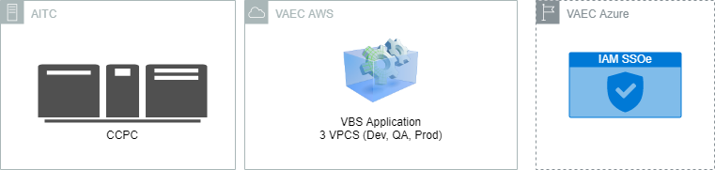

Figure 16 shows location of each of components of the CCVBS application. CCPC resides in AITC. The CCVBS application and all of its components reside in VAEC AWS. The IAM SSOe components reside in VAEC Azure.

#### Conceptual Production String Diagram

Figure 17: Conceptual Production String Diagram

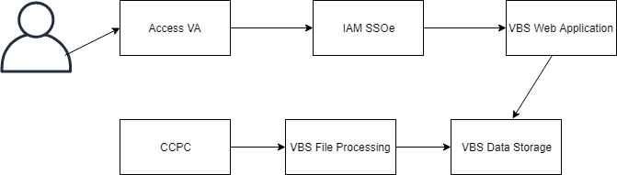

# System Architecture

## Hardware Architecture

Figure 18: Hardware Architecture

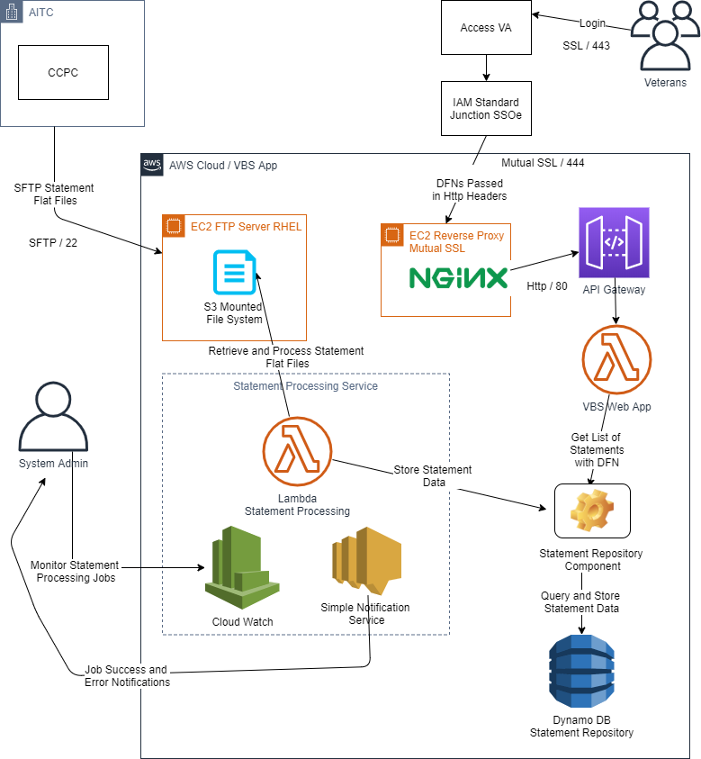

Figure : Application Context Diagram



## Software Architecture

Figure 20: Software Architecture Layers



## Network Architecture

The application contains a VPC for each application environment.

Figure 21: VPC Configuration

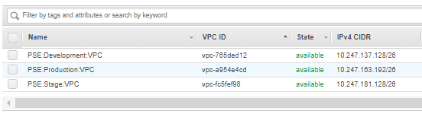

There are only two ports and protocols used to communicate with the CCVBS system; SFTP (Port 22) and SSL (Port 444 and 443). The internal communication within AWS components is SSL and managed by AWS. Port 22 is open to the SFTP server that receives statement batch files from CCPC. Port 444 is open for mutual SSL from the IAM SSOe server that proxies traffic to the CCVBS web application.

## Service Oriented Architecture / ESS

The CCVBS application is independent and totally self-contained and does not currently provide reusable / enterprise shared service interfaces for other applications to reuse.

## Enterprise Architecture

The system is built with .NET Core with Visual Studio and the AWS SDK are all popular approved VA coding tools. Coding style and standards are checked for conformance using Stylecop combined with a style template provided by VA OIT DotNet Standards Committee. Additionally, code security and code quality scans are performed with Fortify.

Appendix A.1 shows the conformance of application components, tools, and protocols to the VA Technical Reference Model (TRM).

# Data Design

## DBMS Files

Data within the CCVBS application is stored with AWS Dynamo DB. Dynamo DB is a key-value NoSQL document database. For the statement table a primary partition key (Guid) is generated by the CCVBS application. A global secondary index (GSI) is keyed with the DFN field (PH_DFN_Number). This allows the application to query statement records using the DFN without doing a table scan.

The following cloud formation script is used to create the tables in DynamoDB:

{

"AWSTemplateFormatVersion": "2010-09-09",

"Description": "",

"Resources": {

"StatementsTable": {

"Type": "AWS::DynamoDB::Table",

"Properties": {

"AttributeDefinitions": [

{

"AttributeName": "Id",

"AttributeType": "S"

},

{

"AttributeName": "PH_DFN_NUMBER",

"AttributeType": "N"

}

],

"GlobalSecondaryIndexes": [

{

"IndexName": "DFNIndex",

"KeySchema": [

{

"AttributeName": "PH_DFN_NUMBER",

"KeyType": "HASH"

}

],

"Projection": {

"ProjectionType": "ALL"

},

"ProvisionedThroughput": {

"ReadCapacityUnits": 1,

"WriteCapacityUnits": 1

}

}

],

"KeySchema": [

{

"AttributeName": "Id",

"KeyType": "HASH"

}

],

"LocalSecondaryIndexes": [],

"ProvisionedThroughput": {

"ReadCapacityUnits": 1,

"WriteCapacityUnits": 1

},

"TableName": "Statements"

}

},

"StationsTable": {

"Type": "AWS::DynamoDB::Table",

"Properties": {

"AttributeDefinitions": [

{

"AttributeName": "FACILITY_NUM",

"AttributeType": "S"

}

],

"KeySchema": [

{

"AttributeName": "FACILITY_NUM",

"KeyType": "HASH"

}

],

"LocalSecondaryIndexes": [],

"ProvisionedThroughput": {

"ReadCapacityUnits": 1,

"WriteCapacityUnits": 1

},

"TableName": "Stations"

}

}

}

}

## Non-DBMS Files

The CCVBS Application receives statement data and station data from CCPC. The format and description of those files is described in Section 7.2.

## Data View

Figure 22: Data Architecture



# Detailed Design

## Hardware Detailed Design

The system uses cloud native hardware. There are two AWS Lambda components. Each Lambda is configured for the maximum memory of 3008MB.

Lambda allocates CPU power linearly in proportion to the amount of memory configured. At 1,792 MB, a function has the equivalent of 1 full vCPU (one vCPU-second of credits per second).

<https://docs.aws.amazon.com/lambda/latest/dg/limits.html>

The EC2 instances used for FTP and NGINX reverse proxy are t2.xlarge in production and t2.medium in lower environments (Dev and QA/UAT). The EC2 instances are mounted to S3 so their file system is essentially unlimited.

Figure 23: Specifications for EC2 T2 Instances

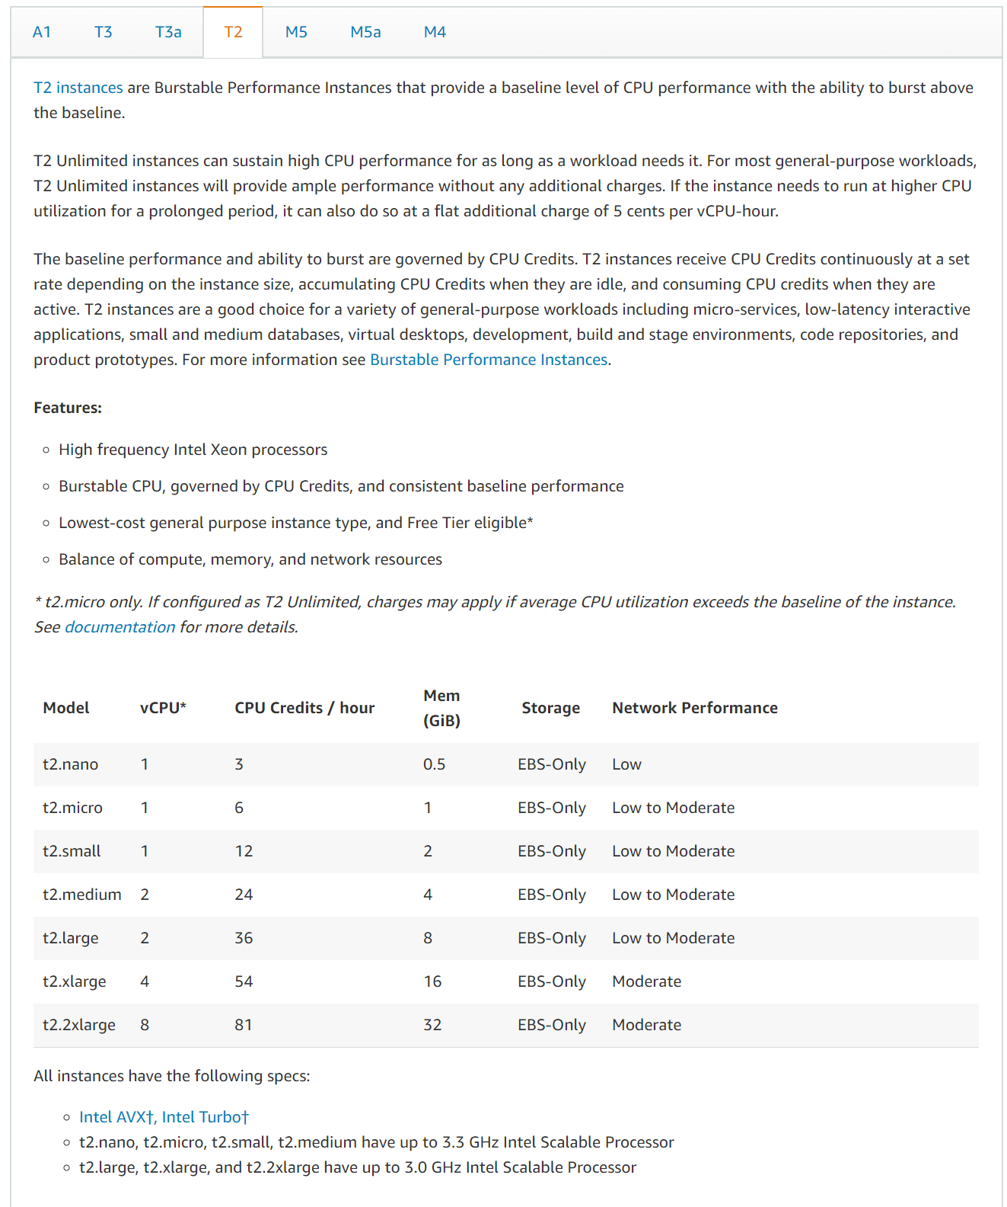

## Software Detailed Design

### Conceptual Design

#### Product Perspective

Figure 24: Product Perspective

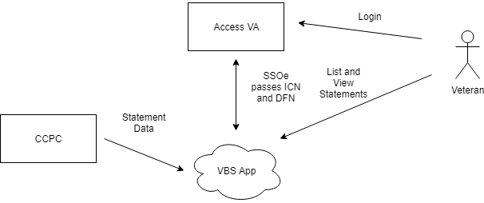

##### User Interfaces

Section 8 fully describes the user interface.

##### Hardware Interfaces

Figure 25: Hardware Interfaces



##### Software Interfaces

Figure 26: Software Interfaces

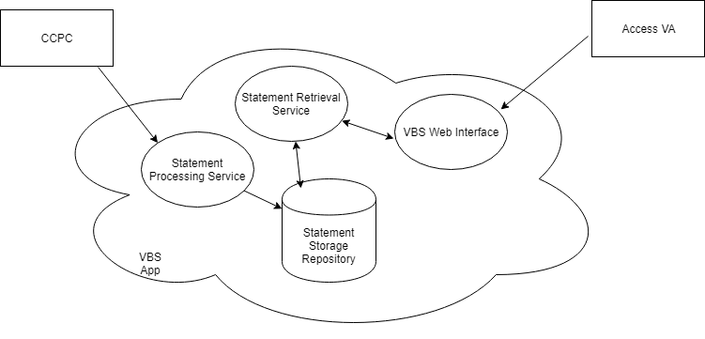

##### Exception Handling

All exception handling and warnings for the CCVBS application are logged through [AWS CloudWatch](https://aws.amazon.com/cloudwatch/). If the application, running via AWS Lambda, throws an exception AWS creates a dead-letter queue. This dead letter queue is tied to an AWS SNS topic which is subscribed to by a CCVBS email group. All application exceptions are emailed to the group and stakeholder are therefore notified. Additionally, the dead letter queue message is logged to CloudWatch. The developer can download the dead letter queue message and use it for debugging purposes locally using the [AWS .NET Mock Lambda Test Tool](https://aws.amazon.com/blogs/developer/debugging-net-core-aws-lambda-functions-using-the-aws-net-mock-lambda-test-tool/).

##### Communications Interfaces

Communication interfaces for the system include TCP, SSL, and SFTP.

##### Memory Constraints

AWS Lambda functions (main platform for the application) are constrained to 3008 MB.

##### Special Operations

Not applicable.

#### Product Features

The CCVBS application allows users to do the following:

* Authenticate via MyHealthEVet, Id.Me or DSLogon credentials
* View a list of statements for the past six months including different statements from different VA locations / facilities grouped by facility and ordered by date.
* Select from the list and either view in the browser or download the statement as a pdf.
* If an error occurs the user can fill out an issue / contact form to submit the issue.

#### User Characteristics

Users are Veterans that have visited a VA facility and may have billing statement.

#### Dependencies and Constraints

The system must be:

* Highly available
* Scalable to a large number of users (all Veterans)
* 508 Compliant
* Security Compliant (FIPS. etc.)
* Privacy Compliant (HIPAA, PII, PHI)
* Enterprise Design Compliant (DEA/STAT)
* Code compliant (VA .NET standards, Fortify Code Quality, Fortify Code Security)
* Available to Veteran users over the internet / externally available

### Specific Requirements

#### Database Repository

All CCVBS data will:

* Stored in Dynamo DB
* Contain at least 6 months worth of statements
* Include statement data for every Veteran
* Include Facility information for all VA facilities
* Be encrypted at rest

#### System Features

##### Routines (Entry Points)

The CCVBS application is organized into five projects as shown below.

Figure 27: CCVBS Application Projects

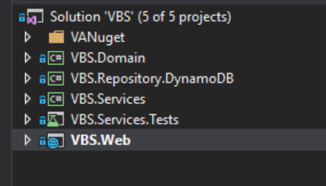

The CCVBS.Domain project includes the data model elements for data for the application. These data model elements are used for persistence / serializing and deserializing application data.

Figure 28: CCVBS Domain Objects

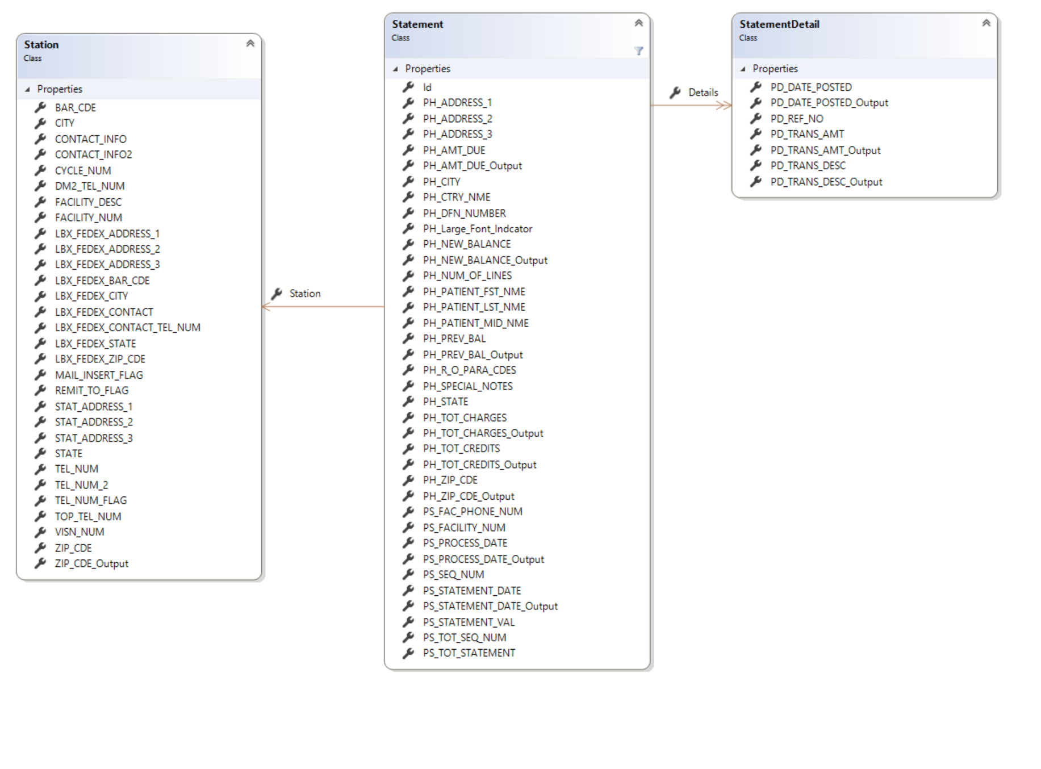

The CCVBS.Repository.DynamoDB project is a shared component that deals with saving and retrieving data from the DynamoDB database.

Figure 29: CCVBS.Repository.DynamoDB Properties and Methods

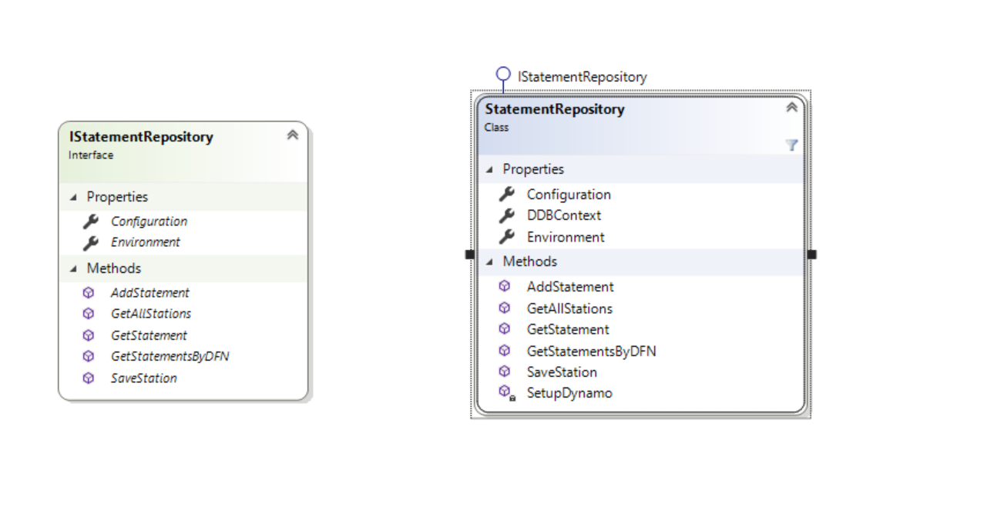

The CCVBS.Services project contains the Lambda for File Processing statements that are received from CCPC.

Figure 30: CCVBS.Services Properties and Methods

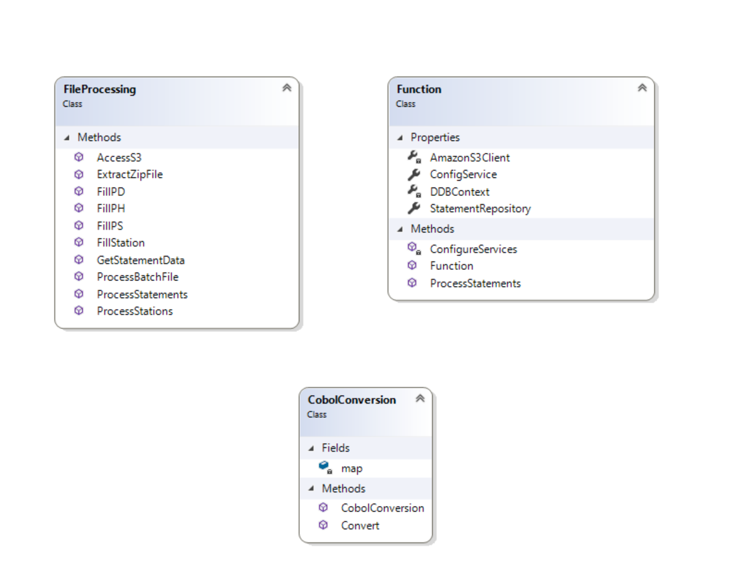

The CCVBS.Services.Tests contains all of the automated unit test for the project for both the CCVBS.Services project and the CCVBS.Web project.

The CCVBS.Web project contains all the code for the web application which runs as an AWS Lambda function.

Figure 31: CCVBS Application Properties and Methods

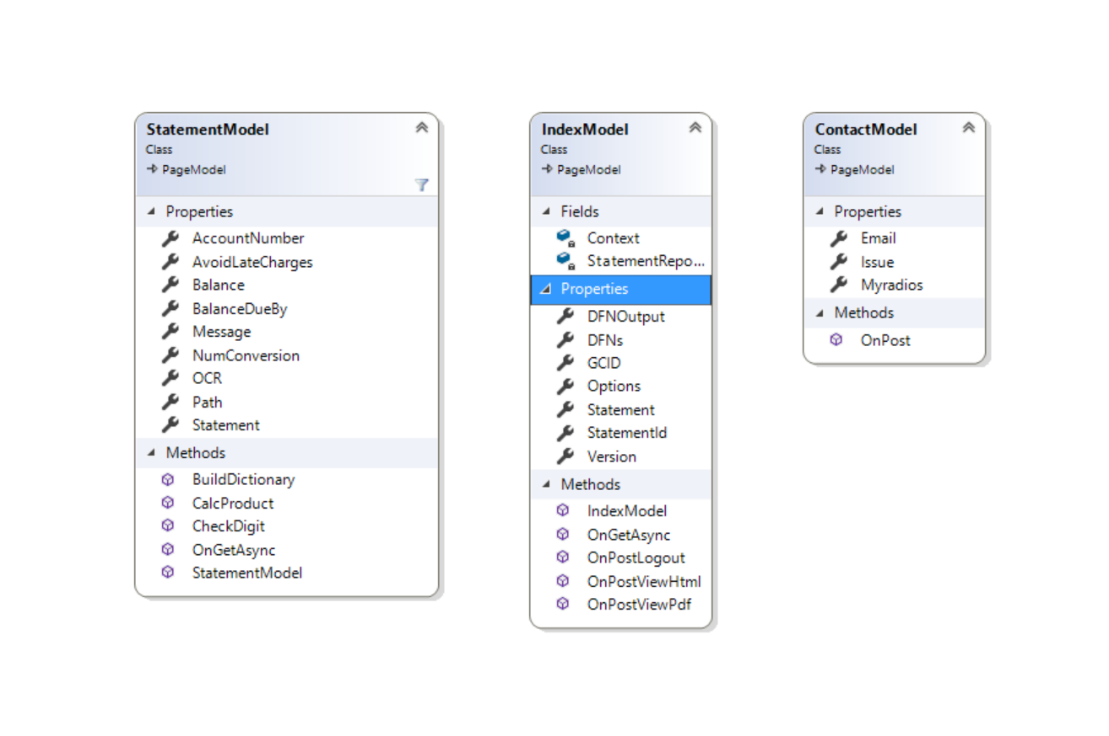

The diagram above shows all of the properties and methods for each of the pages in the CCVBS application. The IndexModel maps to the Index page which displays the list of statements. The StatementModel maps to the Statement page which displays the selected statement to user. The ContactModel maps to the contact page which is used to report any issues.

## Network Detailed Design

See sections 3.3.4.1 and 4.3 for detail describing the network design. Specific detail about IP addresses are attached in the ESECC requests for [Dev and QA/UAT](https://esecc.va.gov/cgweb/MainUI/MainFrame.aspx?ID=1977&moduleName=Change) and [Production](https://esecc.va.gov/cgweb/MainUI/MainFrame.aspx?ID=2009&moduleName=Change).

## Security and Privacy

### Security

User authentication and authorization is provided by IAM via a standard junction SSOe integration as described in Section 7.2.2. Traffic between the IAM reverse proxy is secured via mutual SSL. Mutual SSL uses transport level encryption (SSL) and traffic is specifically restricted on both client and server (to prevent man in the middle) via certificate checking. Additional information on security for data and communication can be found in Section 2.3.2.

Code security is audited via two different scans. The code goes through the Fortify code security audit and is independently verified by the OIS Software Assurance group. Additionally, a WASA scan is performed to identify any web application vulnerabilities.

### Privacy

The CCVBS application protects users privacy via the integration with IAM SSOe. The SSOe sends verified user identifiers (DFN numbers) as described in Section 7.2.2.3. The CCVBS application ensures via server side code checks that the user can only see their personal information (billing statements) that are correlated with their verified identifiers.

## Service Oriented Architecture / ESS Detailed Design

CCVBS is a standalone application. It does not consume or publish any Enterprise services.

# External System Interface Design

## Interface Architecture

CCVBS has two interfaces to external systems shown above. The CCPC mainframe pushes statement batch files via SFTP to a CCVBS FTP server for ingestion. CCVBS integrates with IAM SSOe for authentication and receiving Veteran identifiers.

## Interface Detailed Design

### CCPC Interface

The CCPC mainframe application is used to mail paper statements to Veterans. The CCPC system receives statement data from VistA. The CCVBS application receives the statement data from CCPC. CCPC runs a job that pushes a password protected zip text file with statement data to the SFTP server running in AWS. The SFTP server file system is mounted to AWS S3 using [s3fs-fuse](https://github.com/s3fs-fuse/s3fs-fuse). The statement processing Lambda service receives s3 events that a new file has been put to the directory / bucket and processes the files as they are received.

#### Statement Data

The following table describes the flat file format for the CCPC statement batch file. The column names are the same field names used in the CCVBS data model.

Table 10: CCPC Statement Batch File Flat File Format

| Column Name | Length | Type | Starting Position | Attributes |
| --- | --- | --- | --- | --- |
| STMT-RECORD-TYPE | 2 | Text | 1 | PS |
| PS-SEQ-NUM | 4 | Number | 3 |  |
| PS-TOT-SEQ-NUM | 4 | Number | 7 |  |
| PS-FACILITY-NUM | 5 | Text | 11 |  |
| PS-FAC-PHONE-NUM | 20 | Text | 16 |  |
| PS-TOT-STATEMENT | 4 | Number | 36 |  |
| PS-STATEMENT-VAL | 11 | number | 40 | S9(9)V99 (sign pack) |
| PS-STATEMENT-DATE. | 8 | Text | 51 |  |
| PS-PROCESS-DATE. | 8 | Text | 59 |  |
| Filler | 512 | Text | 67 |  |
| STMT-ERR-FIELD | 1 | Text | 579 | CCPC use only |
| STMT-SEQ-FACILITY | 5 | alph-num | 580 | CCPC use only |
| STMT-SEQ-REMAINDER | 16 | Number | 585 | CCPC use only |
|  |  |  |  |  |
| STMT-RECORD-TYPE | 2 | Text | 1 | PH |
| Filler | 19 | Text | 3 |  |
| PH-PATIENT-LST-NME | 20 | Text | 22 |  |
| PH-PATIENT-FST-NME | 10 | Text | 42 |  |
| PH-PATIENT-MID-NME | 10 | Text | 52 |  |
| PH-ADDRESS-1 | 40 | Number | 62 |  |
| PH-ADDRESS-2 | 40 | number | 102 |  |
| PH-ADDRESS-3 | 40 | Text | 142 |  |
| PH-CITY | 40 | Text | 182 |  |
| PH-STATE | 2 | Text | 222 |  |
| PH-ZIP-CDE. | 11 | Text | 224 | zip5+zip4+zip2 |
| PH-CTRY-NME | 20 | Text | 235 |  |
| PH-AMT-DUE | 9 | Number | 255 | S9(7)V99 (sign pack) |
| PH-PREV-BAL | 9 | Number | 264 | S9(7)V99 (sign pack) |
| PH-TOT-CHARGES | 9 | Number | 273 | S9(7)V99 (sign pack) |
| PH-TOT-CREDITS | 9 | Number | 282 | S9(7)V99 (sign pack) |
| PH-NEW-BALANCE | 9 | Number | 291 | S9(7)V99 (sign pack) |
| PH-SPECIAL-NOTES | 160 | Text | 300 |  |
| PH-R-O-PARA-CDES | 40 | Number | 460 |  |
| PH-NUM-OF-LINES | 3 | Number | 500 | updated if consolidated |
| PH-DFN-NUMBER | 16 | Number | 503 |  |
| PH-Large-Font-Indcator | 1 | Number | 519 |  |
| Filler | 17 | TEXT | 520 |  |
| Filler | 1 | TEXT | 537 |  |
| Filler | 8 | TEXT | 538 |  |
| Filler | 18 | Text | 546 |  |
| Filler | 3 | Number | 564 |  |
| Filler | 1 | Text | 567 |  |
| Filler | 11 | text | 568 |  |
| STMT-ERR-FIELD | 1 | text | 579 | CCPC use only |
| STMT-SEQ-FACILITY | 5 | alph-num | 580 | CCPC use only |
| STMT-SEQ-REMAINDER | 16 | Number | 585 | CCPC use only |
|  |  |  |  |  |
| STMT-RECORD-TYPE | 2 | Text | 1 | PD |
| PD-DATE-POSTED | 8 | Number | 3 | MMDYYYY |
| PD-TRANS-DESC | 50 | Text | 11 |  |
| PD-TRANS-AMT | 9 | Number | 61 | S9(7)V99 (sign pack) |
| PD-REF-NO | 13 | Text | 70 |  |
| Filler | 496 | text | 83 |  |
| STMT-ERR-FIELD | 1 | text | 579 | CCPC use only |
| STMT-SEQ-FACILITY | 5 | alph-num | 580 | CCPC use only |
| STMT-SEQ-REMAINDER | 16 | Number | 585 | CCPC use only |

#### Station Data

CCPC also sends station data from CCPC. The station data is correlated with the statement data to show the correct facility information on the statement.

Table 11: Station Data

| Field Name | Description | Length | New Offset | Attributes |
| --- | --- | --- | --- | --- |
| FACILITY-NUM | AR station number or ‘XXXXX’ will be used to obtain the lockbox address | X(5) | 1 | Unique key |
| VISN-NUM | Vision number | X(2) | 6 |  |
| FACILITY-DESC | Station name (e.g., ‘Temple Medical Center’) | X(40) | 8 |  |
| CYCLE-NUM | Code indicating which print cycle this station belongs to | 9(3) | 48 |  |
| REMIT-TO-FLAG | Flag indicating whether to use the station, the lockbox, or the remit to address for remittance | X(1) | 51 | ‘S’tation, ‘L’ockbox or ‘R’emit address |
| MAIL-INSERT-FLAG | Flag indicating type of inserts to be included when mailing statements for this station | X(1) | 52 | ‘0’ will be indicate normal inserts, subsequent values will be determined as needed. |
| STAT-ADDRESS-1 | First address line | X(40) | 53 |  |
| STAT-ADDRESS-2 | Second address line | X(40) | 93 |  |
| STAT-ADDRESS-3 | Third address line | X(40) | 133 |  |
| CITY | City | X(40) | 173 |  |
| STATE | State | X(2) | 213 |  |
| ZIP-CDE | Zip code | 9(11) | 215 |  |
| BAR-CDE | Bar code of station’s primary address | X(14) | 226 |  |
| TEL-NUM-FLAG | Telephone number flag | X(1) | 240 | Indicates which phone number to use, ‘P’rimary or ‘S’econdary |
| TEL-NUM | Primary telephone number | X(20) | 241 |  |
| TEL-NUM-2 | Secondary telephone number | X(20) | 261 |  |
| CONTACT-INFO | Station contact information | X(30) | 281 | Use for MCCR contact |
| DM2-TEL-NUM | Station DM2 contact’s telephone number | X(20) | 311 | Use for 90-day referral (DM2) contact |
| CONTACT-INFO-2 | Secondary station contact information | X(30) | 331 | Use for IRM contact |
| TOP--TEL-NUM | Station TOP contact’s telephone number | X(20) | 361 | Use for TOP contact |
| LBX-FEDEX-ADDRESS-1 | Station FedEx first address line | X(40) | 381 |  |
| LBX-FEDEX-ADDRESS-2 | Station FedEx second address line | X(40) | 421 |  |
| LBX-FEDEX-ADDRESS-3 | Station FedEx third address line | X(40) | 461 |  |
| LBX-FEDEX-CITY | Station FedEx City | X(40) | 501 |  |
| LBX-FEDEX-STATE | Station FedEx state | X(2) | 541 |  |
| LBX-FEDEX-ZIP-CDE | Station FedEx zip code | 9(11) | 543 |  |
| LBX-FEDEX--BAR-CDE | Station FedEx address’ bar code | X(14) | 554 |  |
| LBX-FEDEX--CONTACT | Station FedEx contact information | X(40) | 568 |  |
| LBX-FEDEX-CONTACT-TEL-NUM | Station FedEx contact’s telephone number | X(20) | 608 |  |
| FILLER |  | X(23) | 628 |  |
|  | Record Length |  | 650 |  |

### IAM Interface

#### Access VA

Users of the CCVBS application login through [Access VA](https://access.va.gov/accessva/).

Figure 32: AccessVA Home Page

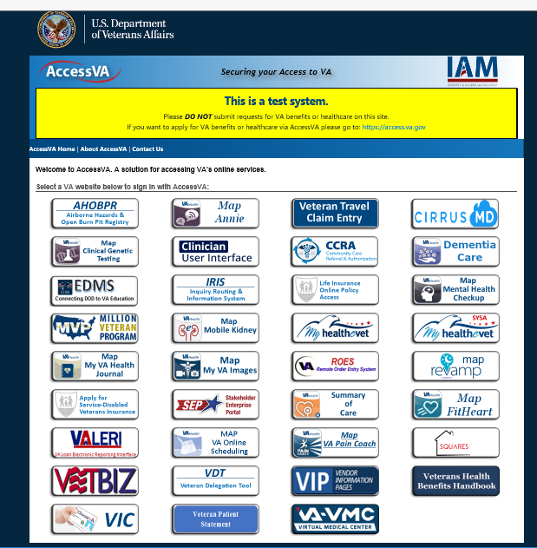

Users click the Veteran Patient Statement button and then go to the CSP select page for CCVBS.

Figure 33: CCVBS Login Options

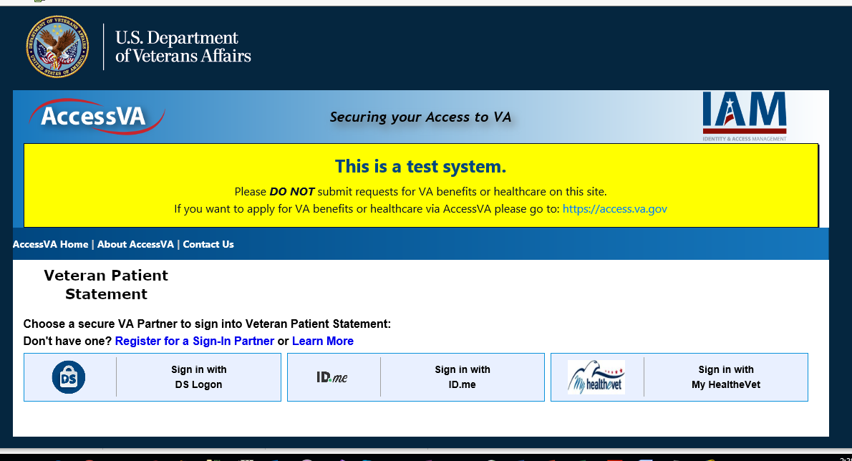

Once the user logs in via one of the available logon methods they are able to view the CCVBS application. The user always sees the IAM url ([https://eauth.va.gov/CCVBS/Prod](https://eauth.va.gov/VBS/Prod)) and all traffic is proxied to the CCVBS application from IAM.

#### Reverse Proxy / Mutual SSL

CCVBS integrates with IAM SSOe in order to provide authorization for Veterans via existing login mechanisms including Id.me, DS Login and MHV credentials. The IAM SSOe pattern is documented ([IAM Playbook](https://vaww.oed.portal.va.gov/sites/vrm/IAM/playbooks/Pages/SSOe/SSOe.aspx)). IAM authorizes users and then reverse proxies traffic to the CCVBS application. Traffic is secured via mutual SSL. Unfortunately, an extra reverse proxy is needed since API Gateway does not [support mutual SSL from incoming traffic currently](https://stackoverflow.com/questions/50650091/two-way-ssl-using-aws-api-gateway). For that reason, CCVBS uses an NGINX server to support mutual SSL from IAM and then reverse proxies traffic again to the CCVBS endpoint in the AWS API Gateway. If and when AWS API Gateway supports incoming mutual SSL, the NGINX component can be removed and IAM can reverse proxy directly to the AWS API Gateway.

#### Authentication Traits / DFN

IAM passes authentication traits related to the authenticated user in the Http headers to the CCVBS application. These traits are documented ([IAM SSOe Authentication Traits](https://vaww.oed.portal.va.gov/sites/vrm/IAM/playbooks/Pages/SSOe/SSOe%20Authentication%20Traits.aspx)). For debugging purposes these traits can be viewed when authenticated ([IAM SSOe Authentication Traits Debug Display](https://int.eauth.va.gov/IAM/)). The data that CCVBS receives from CCPC includes the DFN. The DFN is the facility specific identifier for the Veteran within that instance of VistA. Veterans can have multiple DFNs as they often visit multiple facilities. In order to show the Veteran user the correct statements, CCVBS parses the va_eauth_gcIds trait from the IAM headers, which includes the DFN numbers for the Veteran. Since the DFN numbers are provided by IAM there is no need for an MVI integration. The logins must be correlated to the patients in VistA. There is an MVI patient correlation process that runs in the background which correlates logins from the different login providers to the patient in VistA. This correlation happens based on demographic data (Name, DOB, SSN, etc.). Once this correlation has occurred, the va_eauth_gcIds trait will contain the DFN. It is important for testing purposes to enter the same demographic data when creating test logins that will correlate to VistA patients.

#### Logout

There is a logout button on the CCVBS UI. The logout calls an IAM url to log the user out. The urls for logout across environments are the following:

* <https://int.eauth.va.gov/pkmslogout>
* <https://sqa.eauth.va.gov/pkmslogout>
* <https://preprod.eauth.va.gov/pkmslogout>
* <https://eauth.va.gov/pkmslogout>

# Human-Machine Interface

There are two HTML pages that can be viewed by a Veteran. The first splash page contains a drop-down menu will populate with different select options or statement IDs that are available specifically to the Veteran. Once a date is selected, the Veteran may click one of two buttons.

The **View Statement** button will open a new browser tab to allow Veteran to view a HTML version of the billing statement. This is the second HTML page for screen reader accessibility.

The **Open PDF** button will open a new browser to allow the Veteran to view an Adobe PDF file embedded in the browser window. This ‘print friendly’ page allows the Veteran to print the billing statement if necessary.

## Interface Design Rules

The CCVBS application strictly follows the design format of the U.S. Web Design System which can also be found on [GitHub](https://github.com/uswds/). The USWDS 2.0 is a set of styling standards for government websites. Developers and designers can download the framework and apply to any site. USWDS is a library of code, tools, and guidance to help government teams design and build fast, accessible, mobile-friendly government websites backed by user research and modern best practices.

## Inputs

To access CCVBS, a Veteran must first be authenticated via IAM. After submitting a user name and password on the [Access VA](https://int.access.va.gov/accessva/) website, IAM authenticates the end user which directs the Veteran to the CCVBS application splash page.

The CCVBS splash page contain a small form which includes a drop-down menu and two submit buttons. The drop-down menu is automatically populated with a set of options for the Veteran to choose. These options or statement IDs are based on the Veteran’s monthly billing cycle that will go back no more than 6 months.

Figure 34: CCVBS – View Statement Options

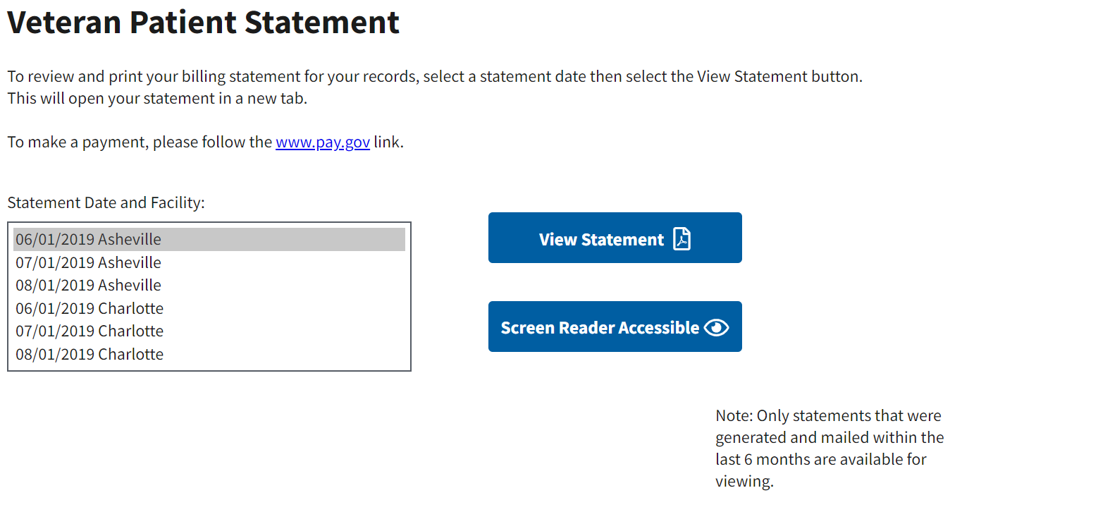

## Outputs

There are only two output scenarios for CCVBS application.

* The **View Statement** button will open a new browser tab that contains an embedded Adobe PDF file in the browser window of the billing statement. The PDF can be downloaded for saving or printing.
* The **Screen Reader Accessible** button will open a new browser tab to display an accessible HTML page that contains the billing statement. Users can tab through the elements in the page using the keyboard tab key making the page accessible and 508 compliant.

## Navigation Hierarchy

Figure 35: Navigation

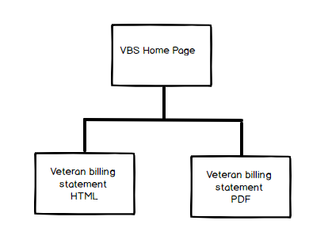

### Screen 1

1. Statement date – plain text label
2. Select box – StatementId
3. View Statement button – open PDF version of billing statement in new browser tab
4. Screen Reader Accessible button – view accessible HTML billing statement in new browser tab

Figure 36: Statement Selection

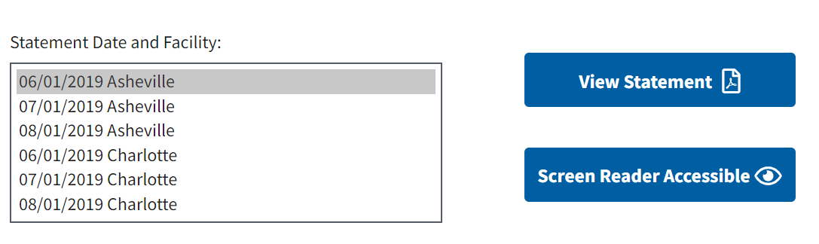

### Screen 2

Figure 37: Example of HTML Page of Sample Billing Statement (1 of 2)

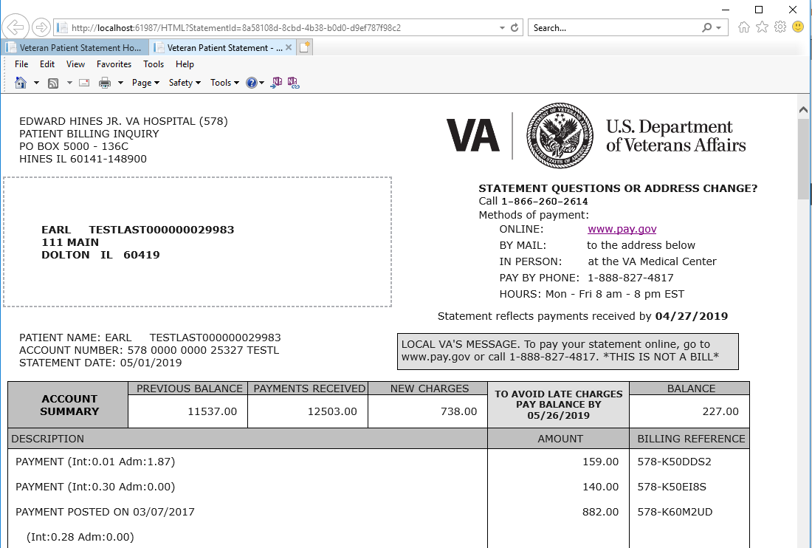

Figure 38: Example of HTML Page of Sample Billing Statement (2 of 2)

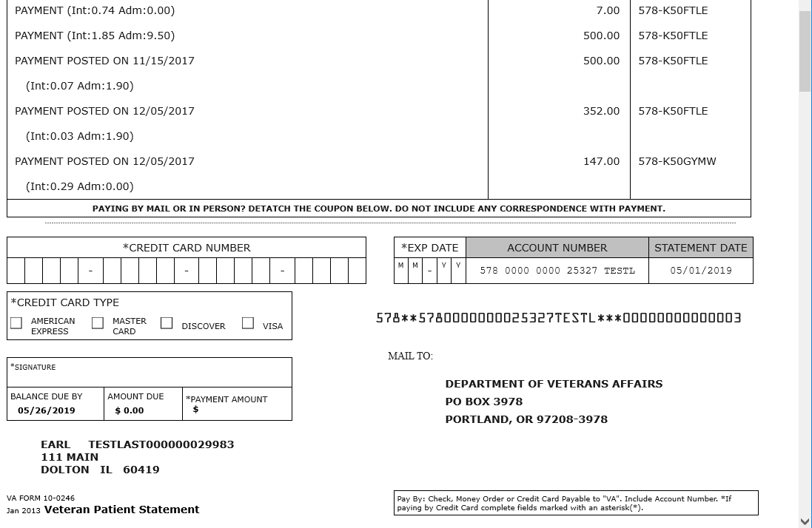

### Screen 3

Figure 39: Example of PDF Page of Sample Billing Statement (1 of 2)

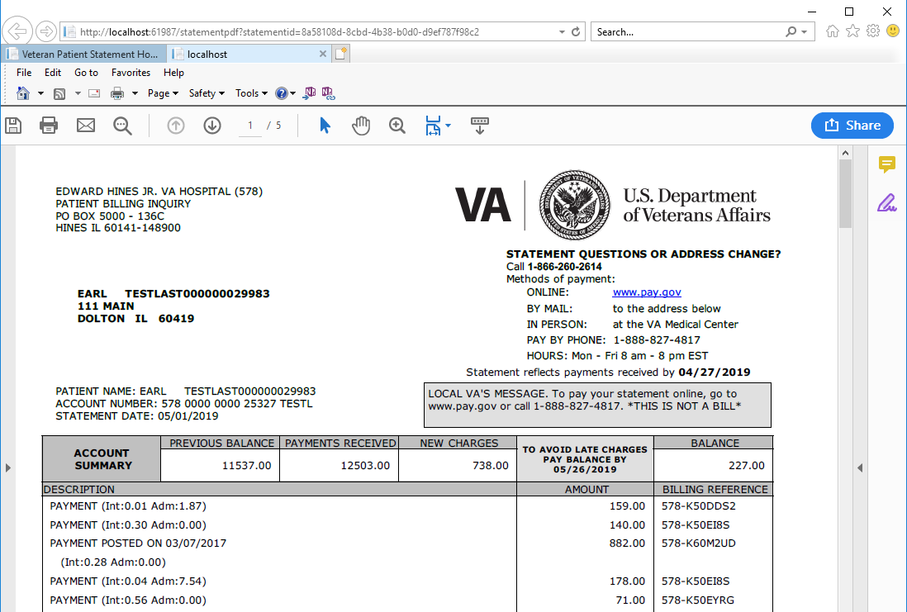

Figure 40: Example of PDF Page of Sample Billing Statement (2 of 2)

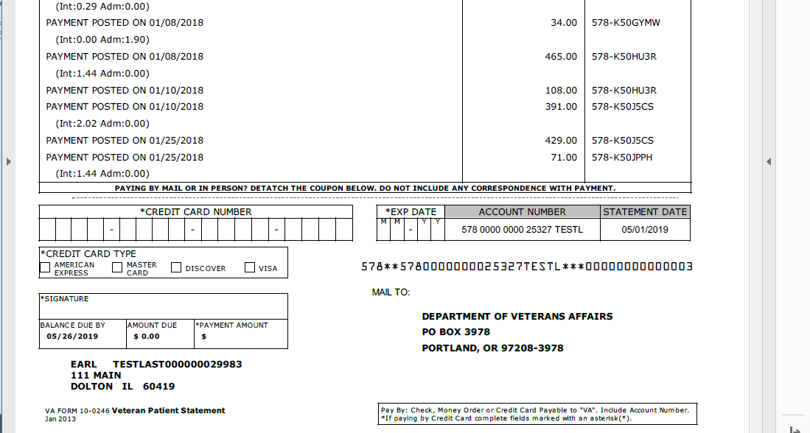

# Attachment A – Approval Signatures

This section is used to document the approval of the System Design Document. The review should be conducted face to face where signatures can be obtained ‘live’ during the review. If unable to conduct a face-to-face meeting then it should be held via LiveMeeting and concurrence captured during the meeting. The Scribe should add /es/name by each position cited. Example provided below.

The Business Sponsor and Project Manager are required to sign.

______________________________________________________________________________

Signed: Date:

< Business Sponsor >

______________________________________________________________________________

Signed: Date:

< Project Manager >

1. Additional Information
   1. Identification of Technology and Standards

TRM Tools and Standard

Table 12: List of Technologies

| Discipline | Technology Name (w/hyperlinked TRM URL) | Version | TRM Decision | Waiver |
| --- | --- | --- | --- | --- |
| Project Management | [IBM Rational Team Concert](https://www.oit.va.gov/Services/TRM/ToolPage.aspx?tid=5085) | 6.0.x | Approved w Constraints | N/A |
| Requirements Management | [IBM Rational Team Concert](https://www.oit.va.gov/Services/TRM/ToolPage.aspx?tid=5085) | 6.0.x | Approved w Constraints | N/A |
| Configuration Management | [IBM Rational Team Concert](https://www.oit.va.gov/Services/TRM/ToolPage.aspx?tid=5085) | 6.0.x | Approved w Constraints | N/A |
| Quality Management | [IBM Rational Team Concert](https://www.oit.va.gov/Services/TRM/ToolPage.aspx?tid=5085) | 6.0.x | Approved w Constraints | N/A |
| Development | [Microsoft Visual Studio](https://www.oit.va.gov/Services/TRM/ToolPage.aspx?tid=5670) | 2015.3 2017.x 2019 (16.x) | Approved w Constraints | N/A |
| Development | [AWS CLI](https://www.oit.va.gov/Services/TRM/ToolPage.aspx?tid=11469) | 1.x | Approved w Constraints | N/A |
| Development | [NGINX](http://trm.oit.va.gov/ToolPage.aspx?tid=6605) | 1.17.x | Approved w Constraints | NA |
| Development | [Microsoft .Net Core](http://trm.oit.va.gov/ToolPage.aspx?tid=10008) | 2.x | Approved w Constraints | N/A |
| Development | [AWS SDK for .NET](http://trm.oit.va.gov/ToolPage.aspx?tid=14205) | 3.3 | Approved w Constraints | N/A |
| Development | [IETF SFTP](http://trm.oit.va.gov/StandardPage.aspx?tid=7031) | RFC 6668 RFC 8332 | Approved w Constraints | N/A |
| Development | [HTTP](http://trm.oit.va.gov/StandardPage.aspx?tid=5332) | 2 | Approved | N/A |

**Open Source Tools**

*TRM is shifting its focus to only include Code libraries that represent development frameworks, tools that are used to produce software but not be embedded into software at runtime, tools that are used to assess or prepare an application before release or monitor the application after release. These types of code libraries will remain on the TRM.*

*To that end, open source code library requests that do not require TRM monitoring will be cancelled and while Java development team can engage the EPMO Open Source Coordination Office (*[*OSSOFT@VA.GOV*](mailto:OSSOFT@VA.GOV)*) for factors to consider when selecting an open source code library for incorporation based on VA open source goals, there is no formal peer review of open source code library selections implemented by EPMO at this time.*

Table 13: List of Open Source Tools Used within CCVBS

| Name | Source Link |
| --- | --- |
| DinkToPdf | <https://github.com/rdvojmoc/DinkToPdf> |
| RazorLight | <https://github.com/toddams/RazorLight> |
| SharpZipLib | <https://github.com/icsharpcode/SharpZipLib> |
| S3fs-fuse | <https://github.com/s3fs-fuse/s3fs-fuse> |

**Cloud Tools**

Cloud tools are not governed by TRM and instead by Fedramp. All tools within the AWS Govcloud are in the Fedramp process. All AWS services used are in either compliant or in the [Fedramp process](https://aws.amazon.com/compliance/services-in-scope/).

The following AWS services are used within the CCVBS application.

* Systems Manager
* API Gateway
* Dynamo DB
* S3
* SNS
* Lambda
* CloudWatch
* CloudTrail
* VPC Flow Logs
  1. Packaging and Installation

Packaging and installation details are described in the DIBORG document.